| ***Exercise 1: Setting Up JUnit*** |
| --- |

### **1. Create a new Java project in your IDE**

Begin by launching your preferred Java IDE—such as **IntelliJ IDEA** or **Eclipse**. Once open, create a new Java project. In IntelliJ, this can be done by clicking **File > New > Project**, choosing Java, and specifying the project name and location. In Eclipse, go to **File > New > Java Project**. This creates the necessary structure and folders (like src/) required to start writing your Java code.

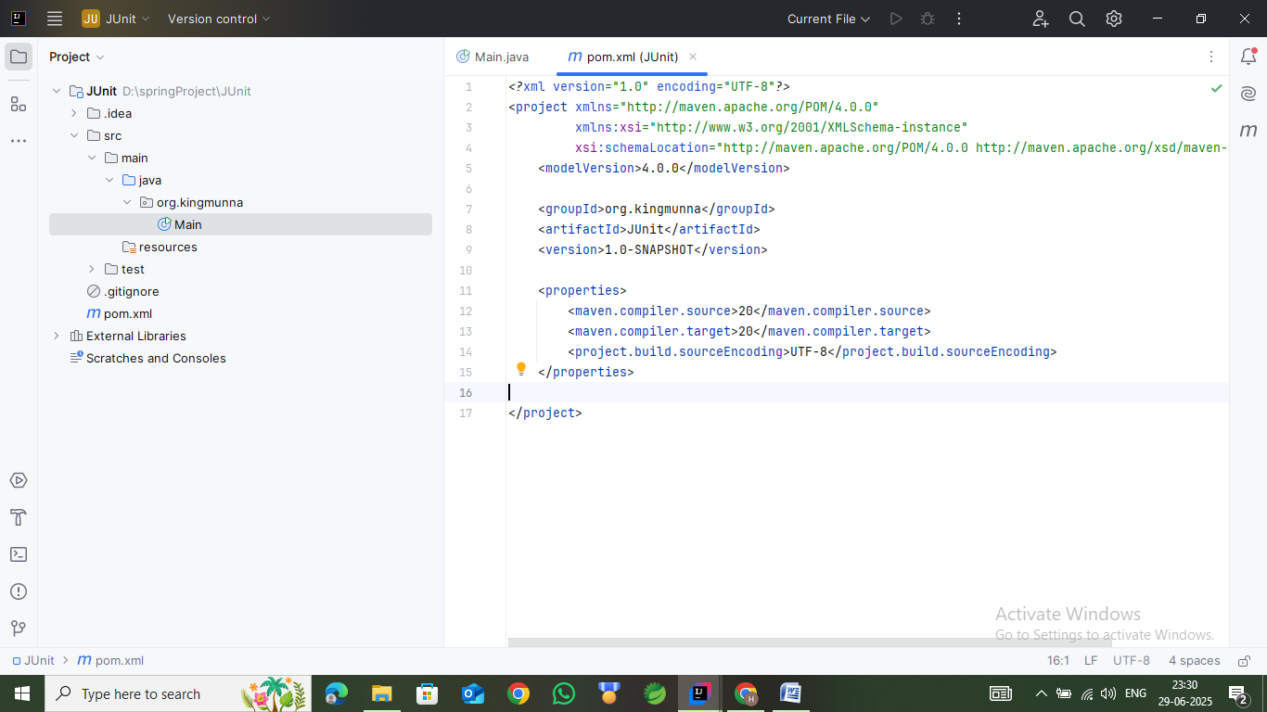

### **2. Add JUnit dependency to your project**

JUnit is a widely used framework for writing unit tests in Java. To use it, you need to add it as a dependency to your project. If you’re using **Maven**, open the pom.xml file located at the root of your project. Inside the <dependencies> section of your pom.xml, add the following dependency block:

<dependency>

<groupId>junit</groupId>

<artifactId>junit</artifactId>

<version>4.13.2</version>

<scope>test</scope>

</dependency>

This tells Maven to download the JUnit 4.13.2 library specifically for test use. Maven will handle the downloading and linking of the library automatically. Click reload (see mouse location in the image below).

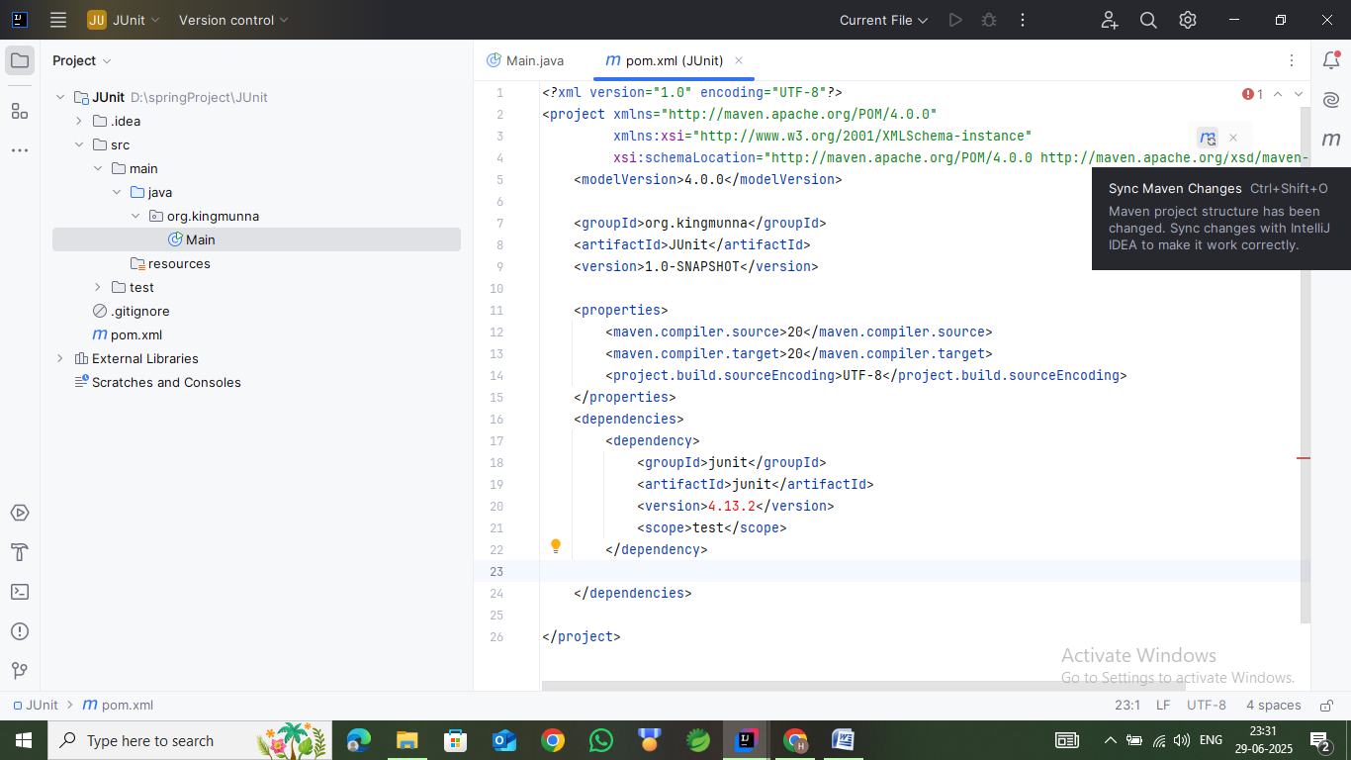

### **3. Create a new test class in your project**

Now that JUnit is set up, it’s time to create a test class. Right-click on the src/test/java folder (or create it if not already present) and select **New > Java Class**. Give it a name that reflects the class you are testing—typically in the format ClassNameTest. For example, if your main class is Calculator.java, you would name the test class CalculatorTest.java.

Inside this test class, you can begin writing your test methods. Annotate each test method with @Test (from org.junit.Test) and use assertion methods like assertEquals(), assertTrue(), or assertNotNull() to check expected results. Here's a quick sample:

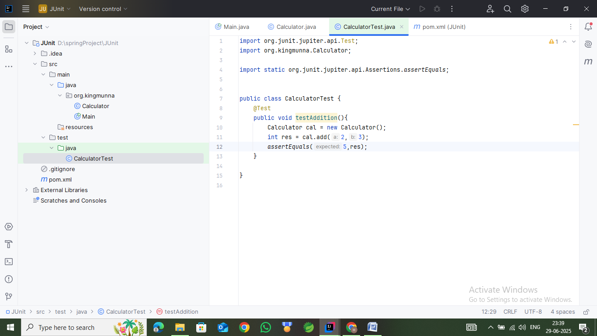

This test checks if the add() method in your Calculator class returns the correct sum. When you run this test class, JUnit will execute the method and report whether it passed or failed.

Right click the program, and click the following :

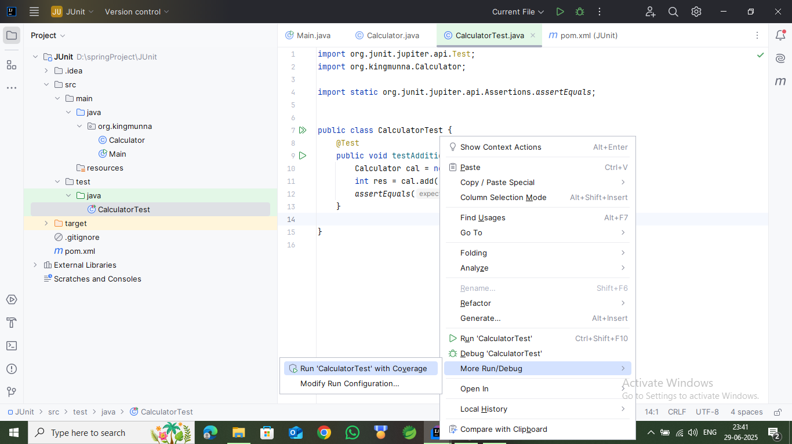

This will result in :

